W4 - PRACTICE
JS – ES6 Functions

 At the end of this practice, you should be able to…
- Use function default argument
- Use arrow functions
- Pass function as a parameter
- Use Destructuring syntax
- Use spread syntax to clone objects

 How to work?

BEFORE THE PRACTICE
- First watch and understand the following pages and videos:
Function basics, default parameter, arrow function, destructuring, spread operator
Video 1,

- Then complete the following quiz (you can re-do it until you have 100% score)
https://forms.gle/FtUHEsoRnV8eBsTx7

DURING THE PRACTICE
- To start the practice. download the start code from Google classroom

How to submit?
- Create a repository on GitHub with the name of this practice:
Ex: C1-S2-PRACTICE
- Push your final code on this GitHub repository (if you are lost, follow this tutorial)
- Finally, submit on Google classroom your GitHub repository URL
Ex: https://github.com/thebest/ C2-S1-PRACTICE.git

UNDERSTAND THE CONCEPTS…
Before starting exercises, explain - in your own words – the benefit of some concepts in JS

What is the benefit of | You explanation
Benefit of function default argument | Default Argument allows a function to use a predefined value when no argument is provided or is undefined.
Benefit of arrow functions | Arrow function provdies a shorter syntax for writing functions
Benefit of the destructuring syntax | Destructuring syntax lets you extract values from arrays or objects into variables directly, making code shorter and easier to read
Benefit of the spread operator | Spread operator allows you to copy, merge, or expand arrays and objects without modifying the original.

EXERCISE 1

In the provided code, there's an array named shoppingCart representing a user's shopping cart with items containing 'name', 'price', and 'quantity' properties.
The current code calculates the total price of items in the shopping cart without using functions.

THE PROBLEM
This code works only for this specific shopping cart. But we want to be able to compute the total price for any shopping cart

YOUR JOB
Your task is to refactor the code by extracting the logic for calculating the total price into a reusable function.

- Write a function named calculateTotalPrice that takes the shoppingCart array as a parameter and returns the total price.

- Check that your code still produces the same result
- Check that your code can work with many shopping carts

let shoppingCart = [
{ name: "Apples", price: 2.5, quantity: 3 },
{ name: "Bananas", price: 1.5, quantity: 2 },
{ name: "Oranges", price: 3, quantity: 1 },
];

// Calculate total price without using functions
let totalPrice = 0;
for (let item of shoppingCart) {
totalPrice += item.price * item.quantity;
}

EXERCISE 2
The originalArray contains some elements.
The function updateArray takes an array, an index, and a new value as parameters, and updates the value at the specified index in the array.

THE PROBLEM
We want the original array to remain unchanged!

YOUR JOB
In the function updateArray, you need to use the spread operator (...) to clone the original array before making modifications.

let originalArray = [1, 2, 3, 4, 5];

function updateArray(array, index, newValue) {
array[index] = newValue;
return array;
}

let updatedArray = updateArray(originalArray, 2, 10);

console.log("Original array:", originalArray); // original array should not be modified...
console.log("Updated array:", updatedArray);

EXERCISE 3
In the provided code, there's a function named findAverage that calculates the average of numbers in an array.
The findAverage function takes an array of numbers as a parameter.

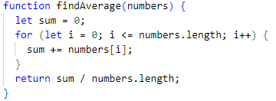

THE PROBLEM
There's a bug in the implementation of the findAverage function that causes it to produce incorrect results (it displays NaN)

YOUR JOB
Your task is to identify and fix the bug in the findAverage function to ensure that it correctly calculates the average of numbers in the array.

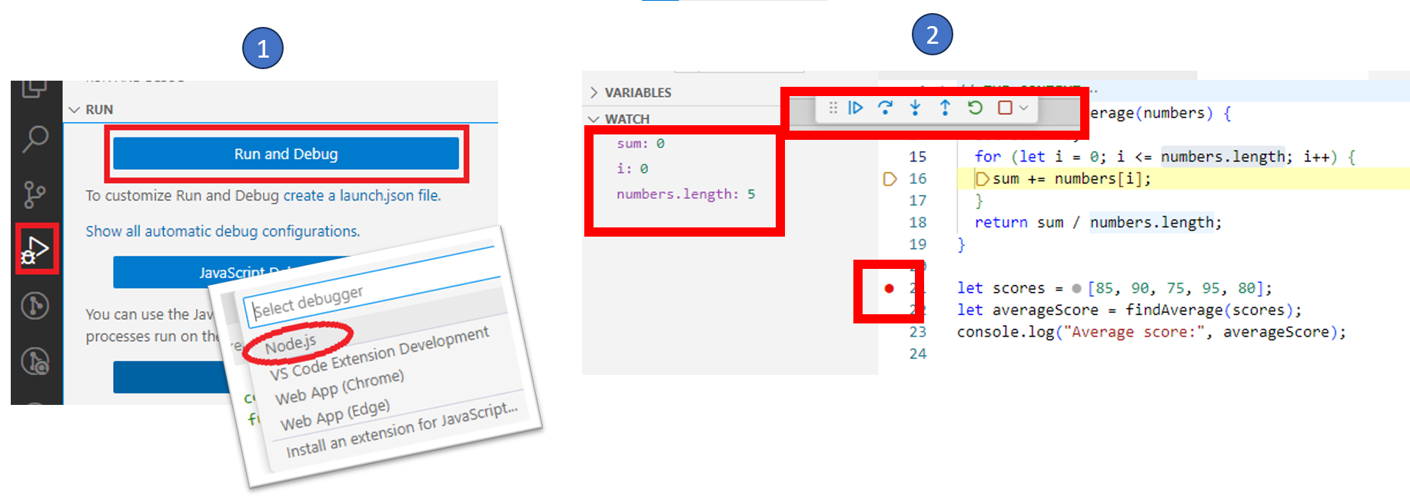
For this exercise, you should launch VScode debugger and diagnostic the bug, step by step

EXERCISE 4
In this exercise you will need to work with 3 array functions: map, filter, reduce
https://developer.mozilla.org/en-US/docs/Web/JavaScript/Reference/Global_Objects/Array/map
https://developer.mozilla.org/en-US/docs/Web/JavaScript/Reference/Global_Objects/Array/filter
https://developer.mozilla.org/en-US/docs/Web/JavaScript/Reference/Global_Objects/Array/reduce

YOUR JOB
Complete the 3 functions with the corresponding code. Everything should ft in 1 line!

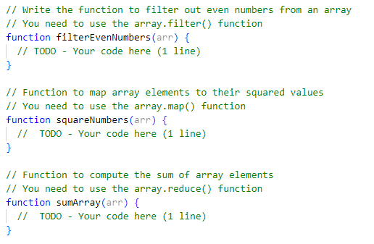

EXERCISE 5

In the provided code, there's an array named students, containing objects representing students with their IDs, names, and grades.

let students = [
{ id: 1, name: "Trang", grade: "A" },
{ id: 2, name: "Hai", grade: "B" },
{ id: 3, name: "Linh", grade: "C" },
];

There's a function named updateStudentGrade() that takes three parameters:
- studentsArray the array of students)
- idToUpdate the ID of the student to update)
- newGrade the new grade to assign to the student).

function updateStudentGrade(studentsArray, idToUpdate, newGrade) { … }

YOUR JOB
Your task is to complete the updateStudentGrade function, following the steps.

Note : You will need to use the following elements : array.findIndex(), spread operator



